Create File Storage with ORM Stack

Contents

1. Introduction 1
2. Workflow diagram to deploy the stack 1
3. Create stack for File Storage 2
4. Plan the Job 6
5. Apply the Job 7
6. Verify in the Console 8
7. Destroy the stack (if required) 9

Introduction
Oracle Cloud Infrastructure File Storage service provides a durable, scalable, secure, enterprise-grade network file system. You can connect to a File Storage service file system from any bare metal, virtual machine, or container instance in your Virtual Cloud Network (VCN). You can also access a file system from outside the VCN using VCN peering, Oracle Cloud Infrastructure FastConnect, and Internet Protocol security (IPSec) virtual private network (VPN).

Large Compute clusters of thousands of instances can use the File Storage service for high-performance shared storage. Storage provisioning is fully managed and automatic as your use scales from a single byte to exabytes without upfront provisioning.

Workflow diagram to deploy the stack

Below diagram shows how the Terraform Artifact are applied in the OCI. While creating a ORM stack, using terraform deliverables Init, Plan and Apply is the flow to provision the resource in the OCI. We can have the deliverables in any of below.
- GitLab/GitHub Repo
- Bitbucket
- Can be in folder/.zip in the local disk
- Object Storage Bucket
- Can be in compartment
- Oracle provided Template


Create stack for File Storage

Go to OCI Console Developer Services Resource Manager Stacks select the compartment Create Stack

My Configuration Folder Browse Select the “File storage” folder that contains the artifacts Upload

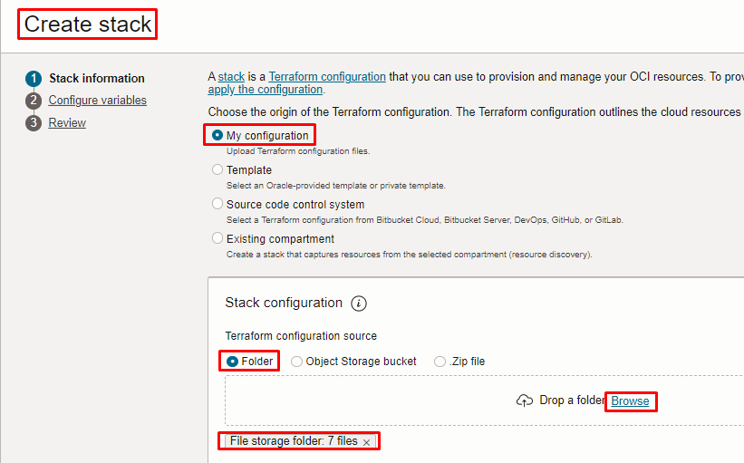
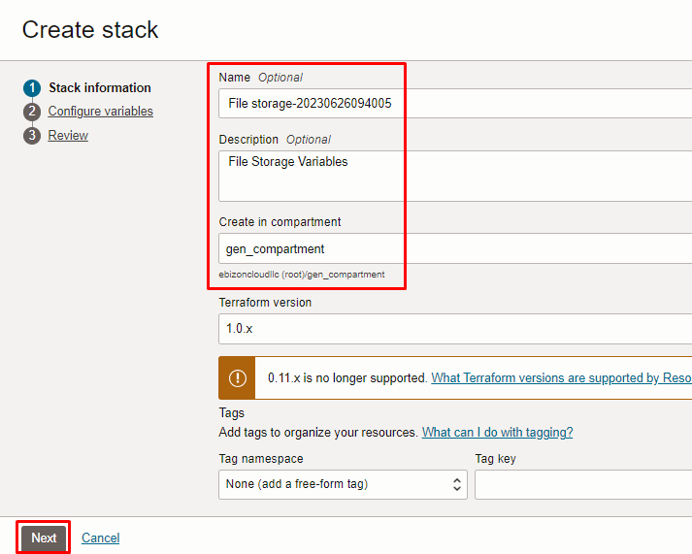

Click “NEXT”

Select the parameters as per the below screen,

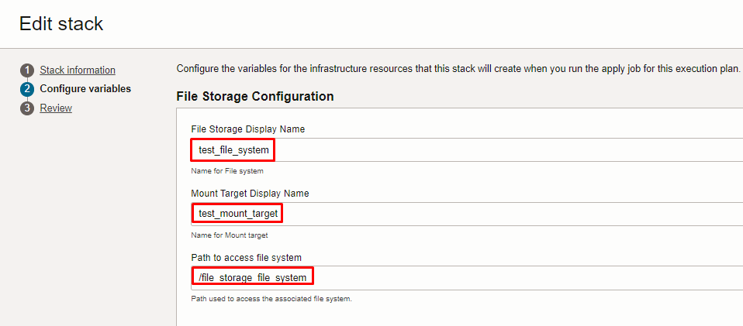
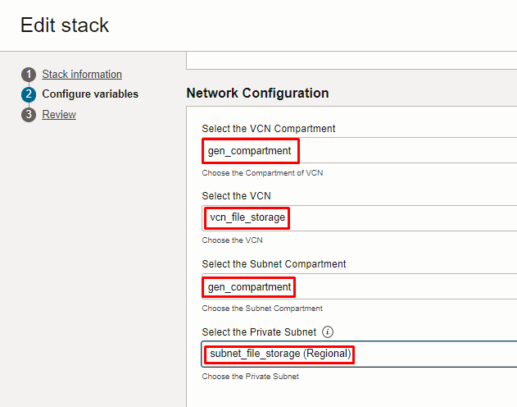

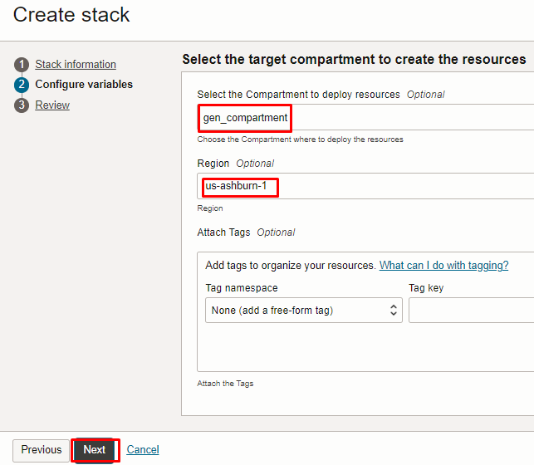

Note: select the right compartment to apply the stack in the OCI

Click “NEXT” Click “CREATE”

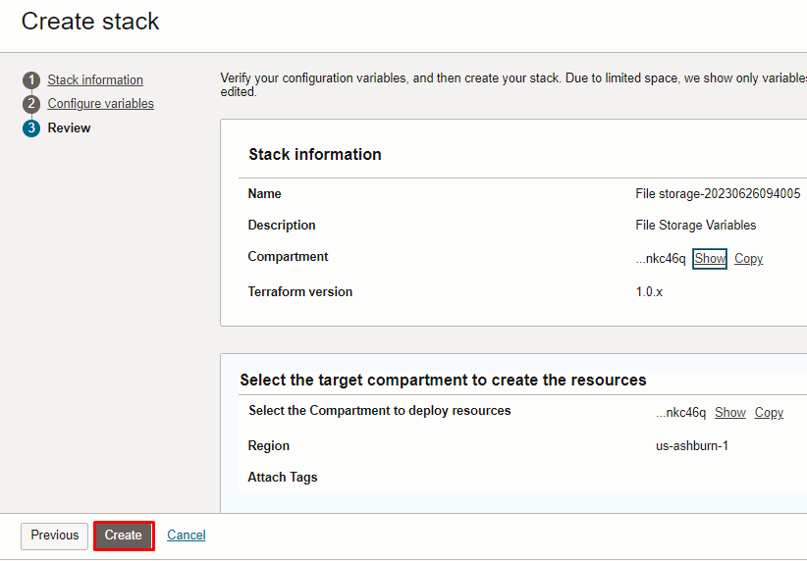

Plan the Job

Click the “Plan”

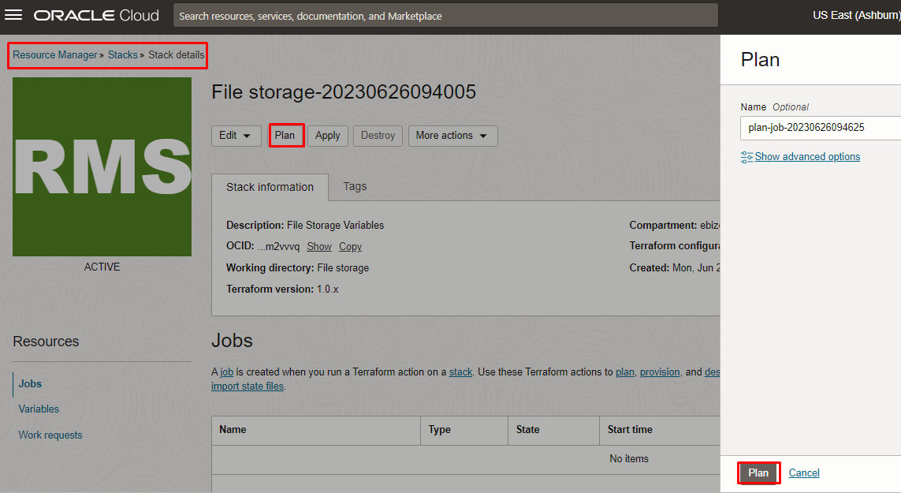

Verify the Plan is successful.

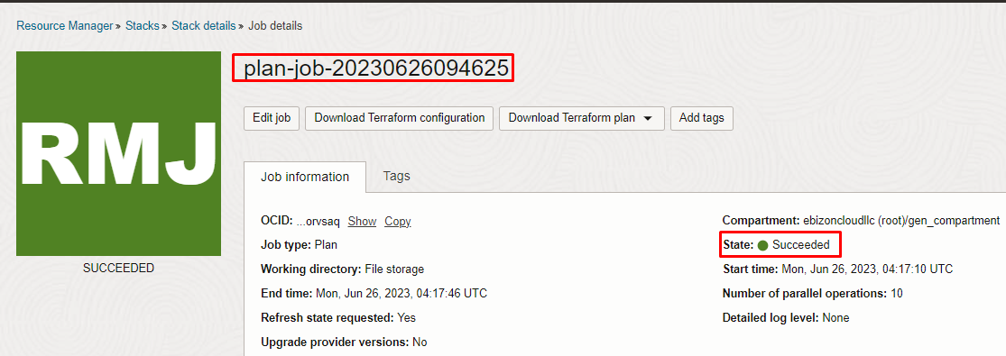
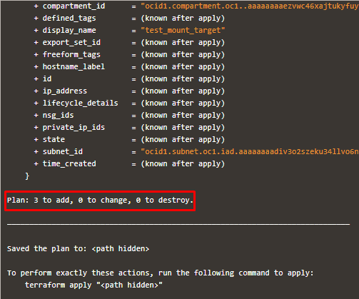

Apply the Job

Once the “plan” is success, now click “Apply”

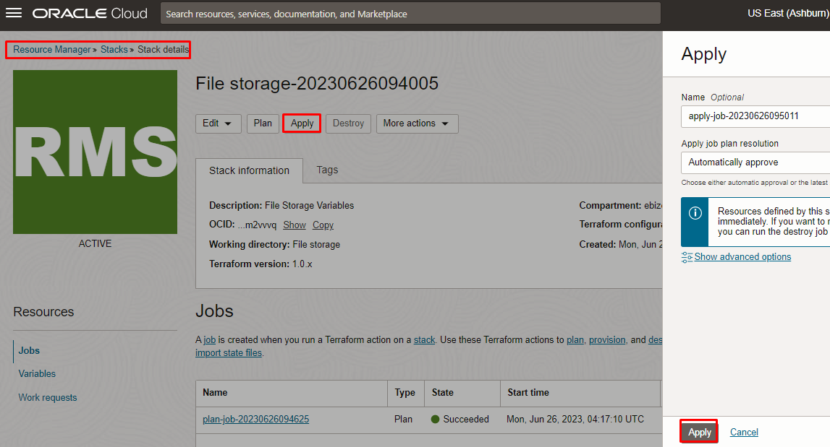

Verify the Apply is successful.
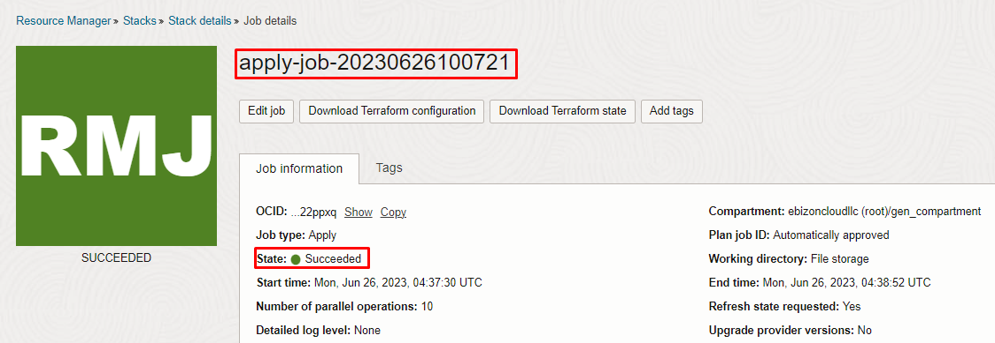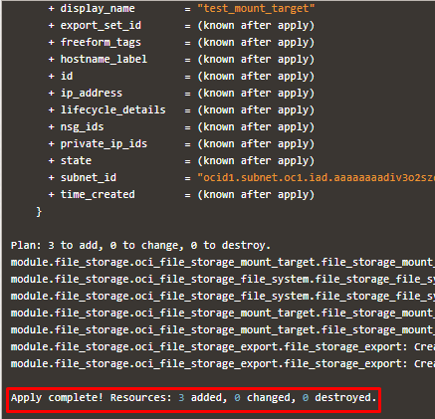

Verify in the Console

Go to OCI Console Storage File Storage
Note: Select the specified compartment (in the step 2) to get the output.

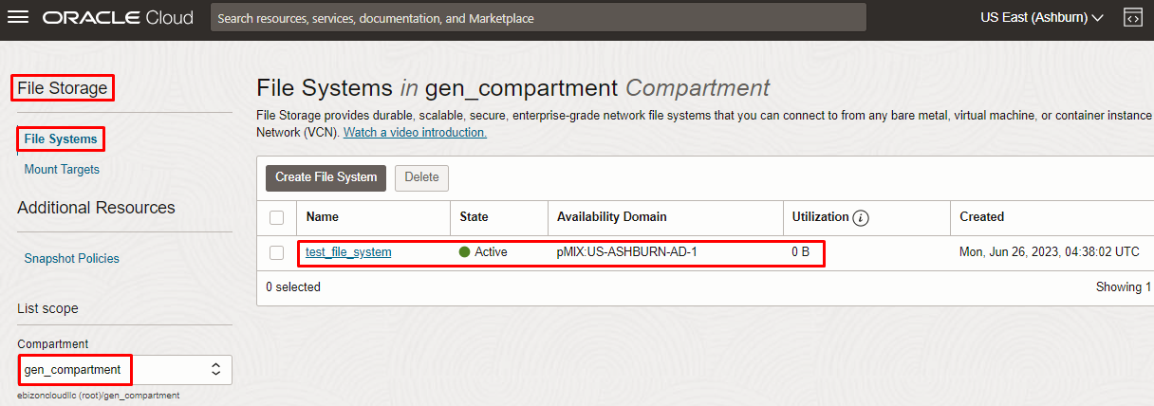
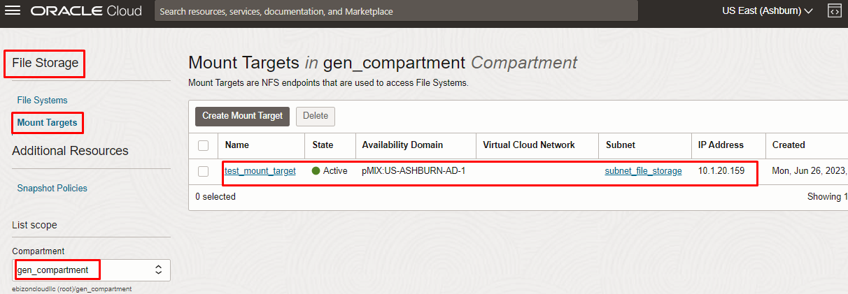

Destroy the stack (if required)

Create a destroy job in Resource Manager to release resources associated with a stack and clean up the tenancy. Once destroyed data cannot be recovered from resources.

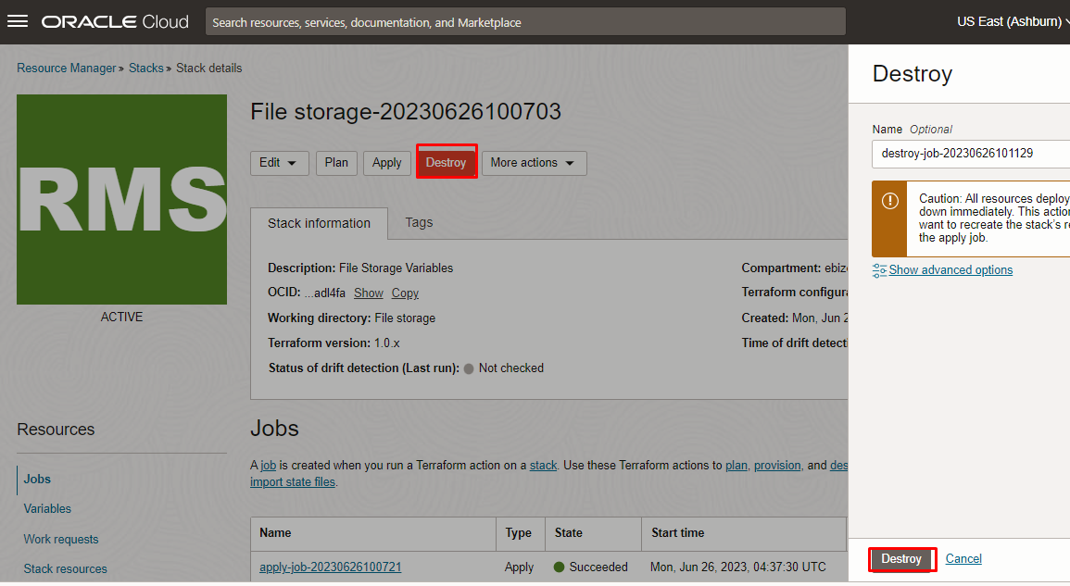

# END #

